Hybrid Off Grid Solar Inverter
BG Series (1KW-5.5KW)

- Rated power : 1KW -5.5KW
- Pure sine wave solar inverter
- Output power factor 1
- High PV input voltage range
- Built-in 30/60/ 80A MPPT solar charger
- Battery equalization function to optimize battery performance and extend life cycle
- Built-in anti-dusk kit for harsh environment

Features

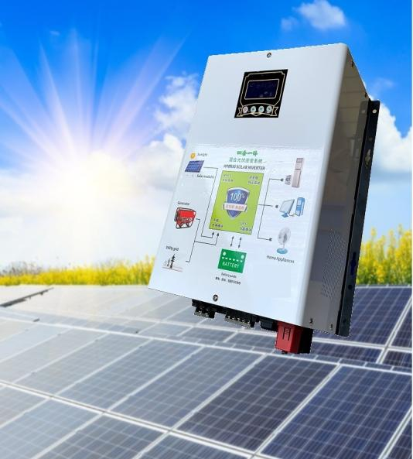

Introduction

BG Series is a multi-functional inverter/charger, combining functions of inverter, solar charger and battery charger to offer uninterruptible power support in portable size. Its comprehensive LCD display offers user-configurable and easy-accessible button operation such as battery charging current, AC/solar charger priority, and acceptable input voltage based on different applications.

MODEL |  | BG1000 | BG-2000 | BG-3000 | BG-4000 | BG5000 | BG5500
Nominal Battery System Voltage |  | 12/24VDC |  | 24/48VDC
INVERTER OUTPUT | Rated Power | 1000W | 2000W | 3000W | 4000W | 5000W | 5500W
 | Surge Power | 2000W | 4000W | 6000W | 8000W | 10000W | 11000W
 | Waveform | Pure Sine Wave
 | AC Voltage Regulation (Batt.Mode) | (220VAC~240VAC)±5%
 | Inverter Efficiency(Peak) | 93%
 | Transfer Time | 10ms (For Personal Computers) 20ms (For Home Appliance)
AC INPUT | Voltage | 230VAC
 | Selectable Voltage Range | 170~280VAC(For pensonal computer) \ 90~280VAC(For Home Appliance) \ 184~253VAC(VDE4105)
 | Frequency Range | 50Hz/60Hz(Auto sensing)
BATTERY | Normal Voltage | 24VDC |  | 48VDC
 | Floating Charge Voltage | 27.4VDC |  | 54.8VDC
 | Overcharge Protection | 30VDC |  | 60VDC
SOLAR CHARGER  &  AC CHARGER | Maximum PV Array Open Circuit Voltage | 145VDC
 | PV Array MPPT Voltage Range | 30~130VDC |  | 64~130VDC
 | Standby Power Consumption | 2W
 | PV Input Power | 2000W |  | 4000W
 | Maximum Solar Charge Current | 30/60/80A
 | Maximum Effciency | 98%
 | Maximum AC Charge Current | 20A |  | 20A
 | Maximum Charge Current | 80A |  | 100A
MECHANICAL SPECIFICATIONS | Machine Dimensions(W*H*D)(mm) | 380*266*153 |  | 380*600*153
 | Package Dimensions(W*H*D)(mm) | 449*358*230 |  | 449*680*230
 | Net Weight(kg) | 10 | 11 | 13.3
 | Gross Weight(kg) | 11.7 | 12 | 16.4
OTHER | Humidity | 5% to 95% Relatiy Humidity (Non-condensing)
 | Operating Temperature | 0°C ~55°C
 | Storage Temperature | -15°C ~60°C

Specification

Back panel printing description Solar system connection

- Input Voltage
- Working Model
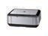
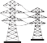
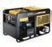
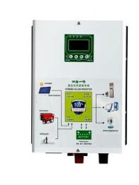
- Output Voltage
SOLAR PANELS
LAPTOP
LIGHTING
AC OUTPUT
PRINTER
INVERTER
TV
AC INPUT
AIR CONDITIONING
GENERATOR
BATTERY
- Solar Panel
- Battery Status
- Loading Application
- Silent Model
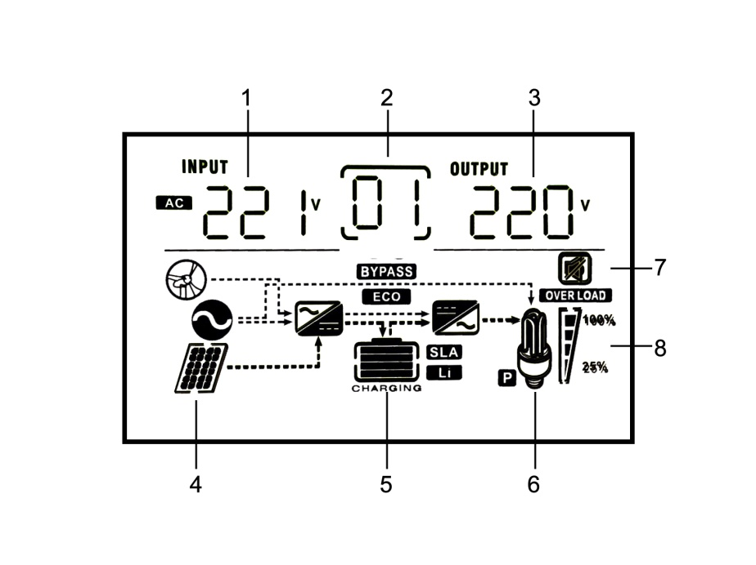
- Loading Status

