USER MANUEL

SOLAR

PRO SERIES
INVERTER

Content

1. Installation Instruction 2

2. Appearance 3

3. Description of panel 5

4. Function and setting 6

5. Connection 7

6. Care and maintenance 9

7. Solution for difficult situation 9

8. Technical parameter 10

1. Installation Instruction

Open up
After opening the package, please check the accessories, including 1 pc of user manual. And please make sure that the inverter is well-protected after transportation, if any damage:

Note: component miss, do not turn on the machine, feedback to the carrier and distributor.

1).Please retain the packing material, those can be used for next delivery if needed.
2).This series of products is heavy (check attachment as reference), please handle carefully when carrying.

1-2. Installation notice

1).Install in an area of well-ventilated, free of water, burning gas and corrosive stuff.

2).Not good to stand on sides, should keep good air inlet from front panel’s bottom and side face of machine, air outlet from back panel’s fan.

3).Environment temperature should remain from 0 to 40 centigrade.

4).When disassembling and operating under low temperature, it may cause water condense, should not turn on until sides of machine being dry, or it will be shock risk.

5).Install the inverter near mains socket or PROitch, in order to pull out mains supply plug to cut off power easily when meeting emergency.

Attention:
< Loading should be turned off before connecting to inverter and turned on the loading one by one after connection completed.
< Connect inverter to accessible socket with over-current protection.
< All power sockets should link with ground protection.
< Inverter may have electricity whether input power cable inserts to mains socket or not. Turning off the inverter does not guarantee electricity does not exist. To ensure no output, should turn off all PROitches and cut the mains power.
< To load inductive appliances such as electromotor, displayer and laser printer, inverter capacity should be two times compared to rated power of the load.

Appearance

1KW-4KW series
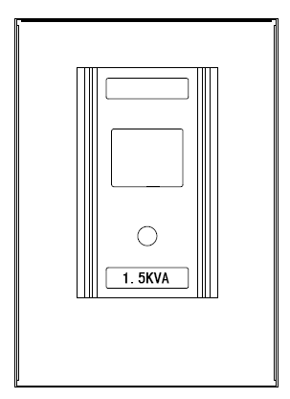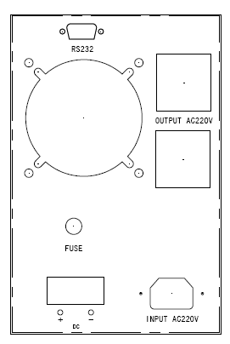
1-1.5KW
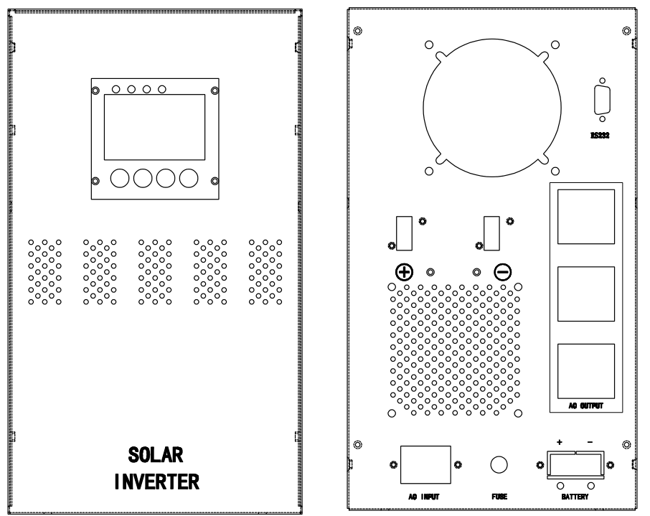
2KW-4KW

4KW-10KW series

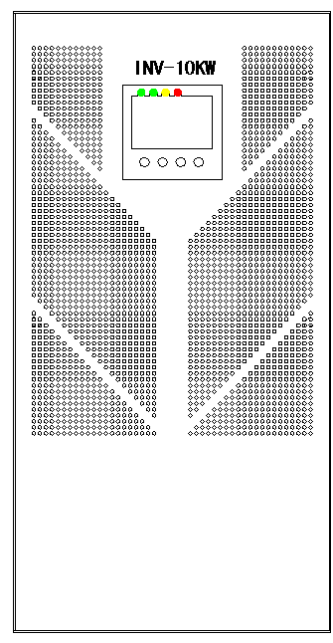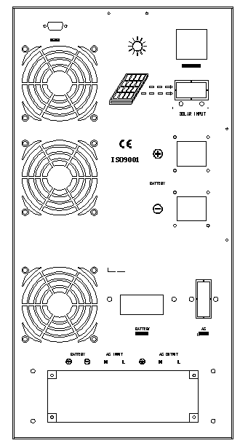

3. Description of panel
Detail of LCD
1 Input Voltage 2 Working Mode 3 Output Voltage
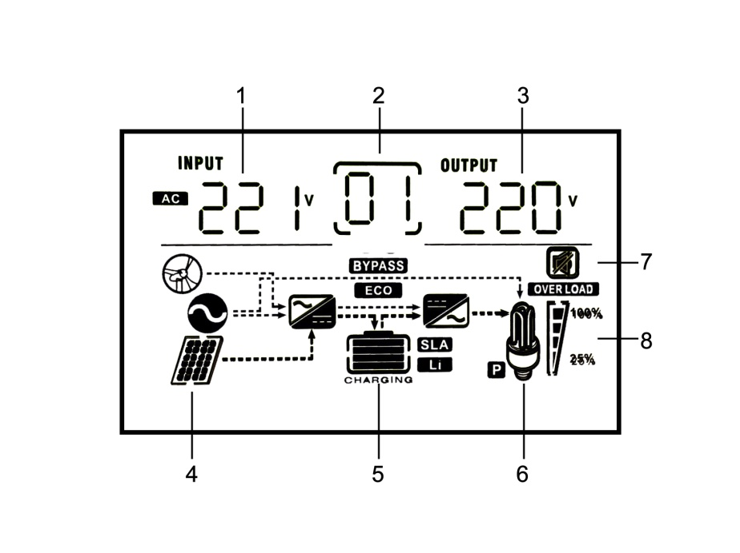
4 Solar Panel 5 Battery Status 6 Loading Application
7 Silent Mode 8 Loading Status

Detail of indicate lamp & button

INPUT | AC input voltage
Hz | output frequency / Working mode
OUTPUT | AC output voltage
BATT. CAPACITY | Battery working condition and capacity
LOAD | Load power
NORMAL | AC input at normal status
FAULT | False signal light
BATTERY | Battery mode
25%--100% | Overload condition
 | ENTER
 | ON/OFF
 | UP
 | DOWN

4. Function and setting
ON/OFF Button: Press for 3 seconds to turn on and 5 seconds turn off.
ENTER Button: Press for 5 seconds start to set Mode P0 to P4. PROitch through UP & DOWN button.
Mode P0- Pre-set. Press ENTER 2 times to end up setting. Auto Exit after 10 seconds' no-ops.
Mode P1- Power supply setting. 01- AC supply in priority, 02- Energy saving. 03- Battery supply in priority, PROitch through UP & DOWN and select through ENTER button.
Position | Float(V) | Position | Float(V)
U0=Gel U.S.A | 13.7V | U4=Gel European | 13.8V
U1=A.G .M.1 | 13.4V | U5=Open lead acid | 13.8V
U2=A.G .M.2 | 13.7V | U6=Calcium (open) | 13.6V
U3=Sealed lead Acid | 13.6V
Mode P2- Battery Type setting. PROitch through UP & DOWN and select battery type through ENTER button.
Mode P3- Charging Current 0-35A selecting. 0-20%-40%-60%-80%-100%, Maximum is 35A, Minimum 0A.
Mode P4- Voice setting. PROitch the Buzzer through UP & DOWN and select through ENTER button.

5. Connection
Attention:
Terminal and output plug are both available to connect the load. Output plug can only allow the loading under 1500W. Loading over 1500W should connect to terminal.

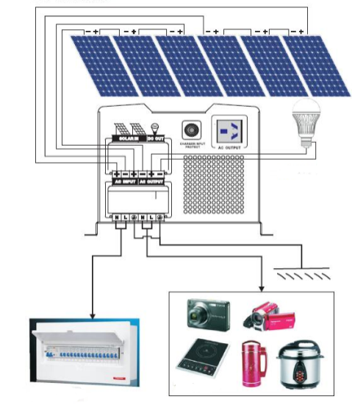
Solar wiring diagram

Note：

If connect to generator, must follow the steps below：

- Start generator, after it go stably, connect its output port to inverter’s input port (to be sure there isn’t any load connecting to inverter at this moment).
- Start the inverter, connect the loads one by one.

- Choose generator with 2 or 3 times capacity compared to inverter.
- Solar inverter’s panel and connection is different from common model.

- The voltage of solar panel should follow the Technical parameter.

Back panel connection
BATTERY Negative | Battery negative polarity connection
BATTERY Positive | Battery positive polarity connection
AC INPUT | AC input connection
AC OUTPUT | Universal socket output or terminal output
FUSE AC INPUT | Ac input voltage over current protection
FUSE AC OUTPUT | Ac output voltage over current protection

Note：

If connect to generator, must follow the steps below：

- Start generator, after it go stably, connect its output port to inverter’s input port (to be sure there isn’t any load connecting to inverter at this moment).
- Start the inverter, connect the loads one by one.

- Choose generator with 2 or 3 times capacity compared to inverter.
- Solar inverter’s panel and connection is different from common model.

- The voltage of solar panel should follow the Technical parameter.

6. Care and maintenance
●This series of inverter fairly needs maintenance. Turn to battery charge mode to extend the life of battery.

●discharge and charge the batteries at least 1 time every 6 months. Charging time should not be less than 12 hours.
●In high temperature area, battery should be charged and discharged every 2 months and standard charging time is not less than 12 hours.
●Basically batteries works 3-5 years, should replace when working not well.

●Ask professionals to replace the batteries.

Note：

- Before replacing battery, must PROitch off battery, inverter and mains supply.

- Put off the metal object like ring, watch etc.

- Use insulated tool and avoid putting any tool and metal object on battery.

- When connecting battery, it may strike some unharmful sparks.
- Do not make converse connection.

7. Solution for difficult situation

False | Cause | Solution
No city power input | Recoverable fuse popup | Press fuse back
Terminal heating | Fault or loose connection | Reconnect
Auto PROitch off with loads | Battery no power or overload | Charge battery or reduce loads
PROitch on failure | Fault connection with city power or battery | Check connection with battery or reconnect
Alarm when PROitch on | Battery no energy or overload | Charge battery or reduce loads
Buzzer screams 2 secs every 3 secs | Over temperature alarm (85℃-alarm，90℃-shut down) | Check if fan or vents jammed
Fan’s speed not stable | Smart control according to temperature | Leave it

Technical parameter
（1）
MODEL |  | PRO  1000VA | PRO  1500VA |  | PRO  2000VA |  |  | PRO  3000VA |  |  | PRO  4000VA
RATED CAPACITY |  | 1000W | 1500W |  | 1500W |  |  | 2000W |  |  | 3000W
INPUT | VOLTAGE | (85-135)//(165-275)VAC
 | FREQUENCY | 40~60HZ
OUTPUT | VOLTAGE | AC110V/120V//220V/230V±2%（BATTERY MODE）
 | FREQUENCY | 50/60HZ±2%（BATTERY MODE）
OUTPUT WAVEFORM |  | PURE SINEWAVE
EFFICIENCY |  | ＞80%
BATTERY |  | OPTIONAL
BATTERY RATED VOLTAGE |  | 12/24/48/96VDC |  |  |  |  | 24/48/96VDC
MAX AC CHARGING CURRENT |  | 0-40A(OPTIONAL)
SOLAR INPUT VOLTAGE |  | PWM (12V TO 25V, 24V TO 50V, 48V TO 80V)  MPPT (12/24/48V TO 72V/150V)
SOLAR CHARGE CURRENT |  | 10A/20A/30A/50A/100A (OPTIONAL)
PROTECT |  | OVERLOAD,SHORT CIRCUIT,BATTERY HIGH AND LOW VOLTAGE AND AC INPUT HIGH AND LOW VOLTAGE PROTECTION
TRANSFER TIME |  | ≤4MS
CAPACITY OF OVERLOAD |  | 110-125% TURN TO BYPASS AFTER 60 SECS,150%MAINTAIN 10S AND THEN SHUT DOWN
COMMUNICATION PORT |  | RS-232/USB(OPTIONAL)
OPERATING ENVIROMENT | TEMPERATURE | -40~55℃
 | HUMIDITY | 10%-90%
CASE SIZE:L*W*H(mm) |  | 380*140*215 |  |  |  | 430*195*360
PACKAGE SIZE:L*W*H(mm) |  | 490*405*285 |  |  |  | 535*250*410
N.W/G.W(kg) |  | 15/18kg |  | 18/21kg |  | 20/21kg |  |  | 23/26kg | 26/29kg

（2）
MODEL |  | PRO  5000VA | PRO  6250VA | PRO  7500VA | PRO  10000VA
RATED CAPACITY |  | 4000W | 5000W | 6000W | 8000W
INPUT | VOLTAGE | (85V-135V)/(165-265)VAC
 | FREQUENCY | 45-65HZ
OUTPUT | VOLTAGE | AC110V/120V//220V/230V±2%（BATTERY MODE）
 | FREQUENCY | 50/60HZ±1%（BATTERY MODE）
OUTPUT WAVEFORM |  | PURE SINEWAVE
EFFICIENCY |  | ＞85%
BATTERY |  | OPTIONAL
BATTERY RATED VOLTAGE |  | 12/24/48VDC |  | 24/48/96VDC
MAX AC CHARGING CURRENT |  | 0-40A(OPTIONAL)
SOLAR INPUT VOLTAGE |  | PWM (12V TO 25V, 24V TO 50V, 48V TO 80V)  MPPT (12/24/48V TO 72V/150V)
SOLAR CHARGE CURRENT |  | 10A/20A/30A/50A/100A (OPTIONAL)
PROTECT |  | OVERLOAD,SHORT CIRCUIT,BATTERY HIGH AND LOW VOLTAGE AND AC INPUT HIGH AND LOW VOLTAGE PROTECTION
TRANSFER TIME |  | ≤4MS
CAPACITY OF OVERLOAD |  | 110-125% TURN TO BYPASS AFTER 60 SECS,150%MAINTAIN 10S AND THEN SHUT DOWN
COMMUNICATION PORT |  | RS-232/USB(OPTIONAL)
OPERATING ENVIROMENT | TEMPERATURE | -40~55℃
 | HUMIDITY | 10%-90%
CASE SIZE:L*W*H(mm) |  | 535*265*585mm
PACKAGE SIZE:L*W*H(mm) |  | 665*375*765mm
N.W/G.W(kg) |  | 38/42kg | 42/45kg | 45/50kg | 50/55kg

