Lithium battery ups BX-3000A2-C
Product Specification
1 . Product description
The Smart on-line ups is lightweight, portable and beautiful with large capacity lithium electricity which surpassing other product in the world. The products use progressive lithium battery workmanship. Outputting powerful energy providing two types different voltage mode AC/DC. For adaptive different electronic products demand. The product can use as on-line UPS or pre-emergency standby power. Meeting power requirements of most mobile electronic products.
The product include many lithium battery. The total capacity 48V 26-41AH /1248~1986Wh can provide outpouring .when the power cut ,the product can provide traditional desktop model at home for 3~5 hours under starting up circumstances. At the same time ,can use for indoor or outdoor standby or meet an emergency power and other application. 220V/12V/5V DC/AC outputting can be suitable for different equipments, just like mobile phone, tablet PC, laptop, small printer, some kinds lanterns, fish tank heater, photographic, electrombile ,medical treatment equipments and so on .Our product abandon some weakness from traditional UPS power.it is necessary for traveling, outdoor working, camping out and mountaineering risk.

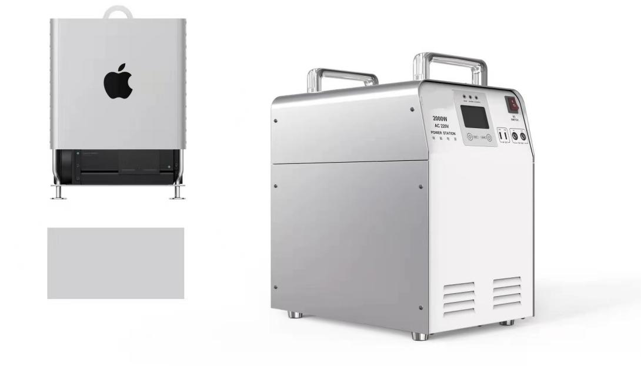

BX-3000VA

2. Function introduction and instruction
1.Front panel description

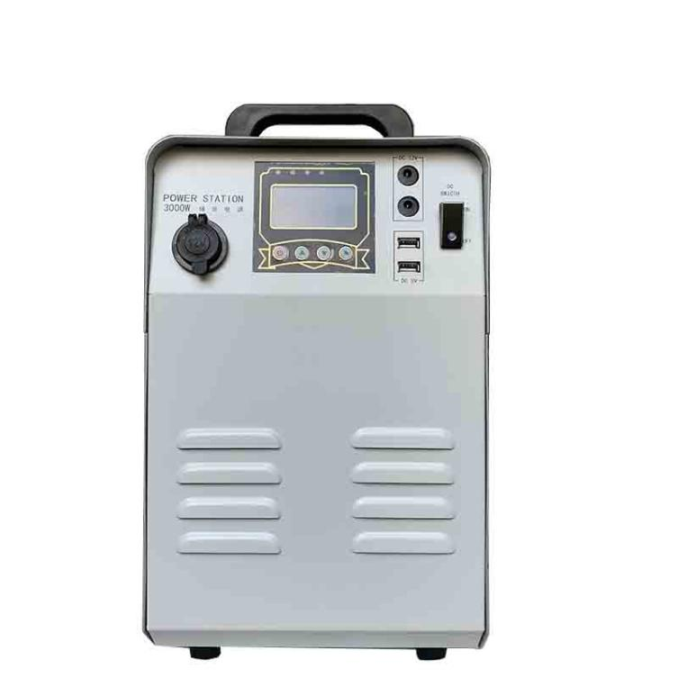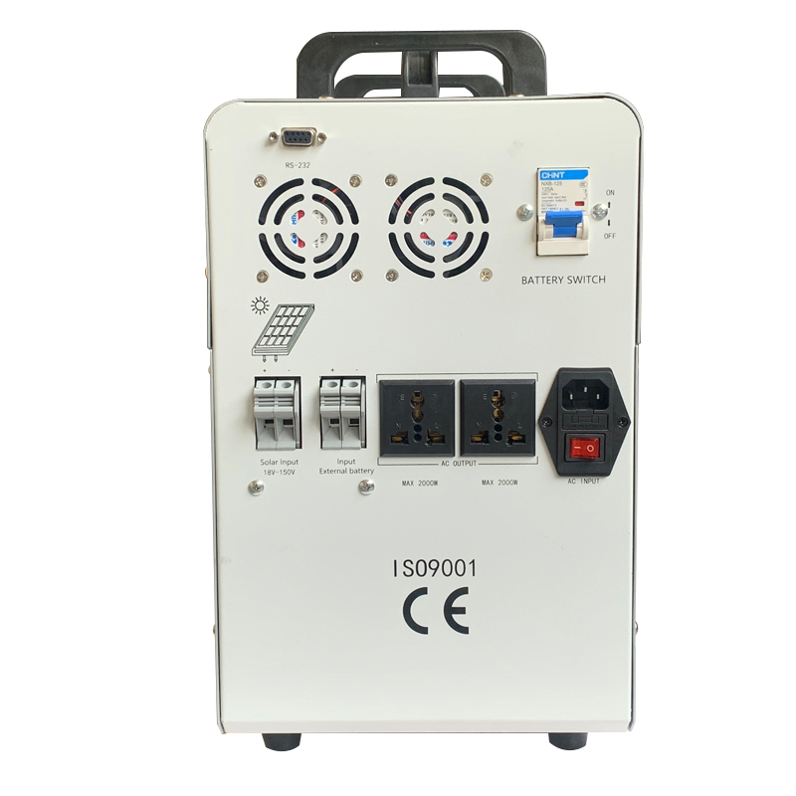

3. Description of panel
Detail of LCD
1 Input Voltage 2 Working Mode 3 Output Voltage
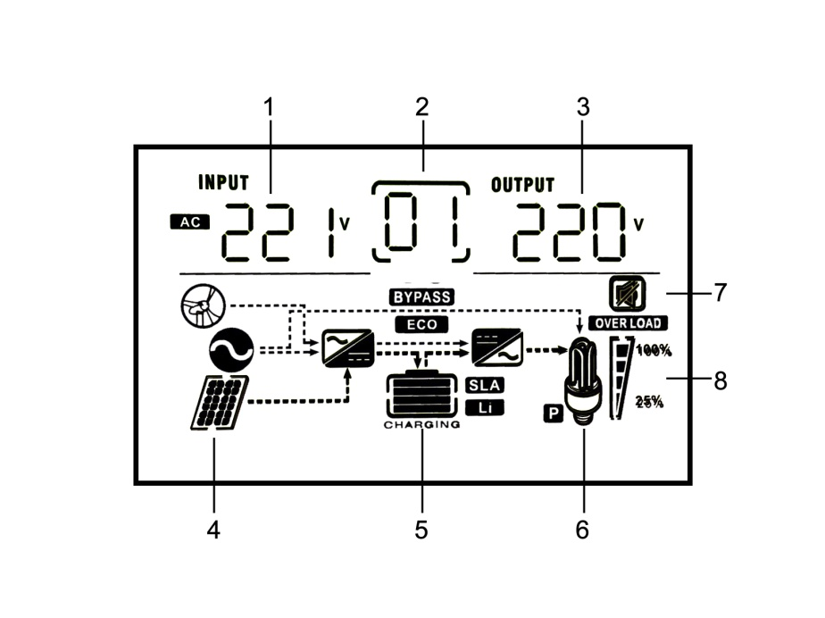
4 Solar Panel 5 Battery Status 6 Loading Application
7 Silent Mode 8 Loading Status

Detail of indicate lamp & button

INPUT | AC input voltage
Hz | output frequency / Working mode
OUTPUT | AC output voltage
BATT. CAPACITY | Battery working condition and capacity
LOAD | Load power
NORMAL | AC input at normal status
FAULT | False signal light
BATTERY | Battery mode
25%--100% | Overload condition
 | ENTER
 | ON/OFF
 | UP
 | DOWN

4. Function and setting
ON/OFF Button: Press for 3 seconds to turn on and 5 seconds turn off.
ENTER Button: Press for 5 seconds start to set Mode P0 to P4. PROitch through UP & DOWN button.
Mode P0- Pre-set. Press ENTER 2 times to end up setting. Auto Exit after 10 seconds' no-ops.
Mode P1- Power supply setting. 01- AC supply in priority, 02- Energy saving. 03- Battery supply in priority, PROitch through UP & DOWN and select through ENTER button.
Position | Float(V) | Position | Float(V)
U0=Gel U.S.A | 13.7V | U4=Gel European | 13.8V
U1=A.G .M.1 | 13.4V | U5=Open lead acid | 13.8V
U2=A.G .M.2 | 13.7V | U6=Calcium (open) | 13.6V
U3=Sealed lead Acid | 13.6V
Mode P2- Battery Type setting. PROitch through UP & DOWN and select battery type through ENTER button.
Mode P3- Charging Current 0-35A selecting. 0-20%-40%-60%-80%-100%, Maximum is 35A, Minimum 0A.
Mode P4- Voice setting. PROitch the Buzzer through UP & DOWN and select through ENTER button.

5. Connection
Attention:
Terminal and output plug are both available to connect the load. Output plug can only allow the loading under 1500W. Loading over 1500W should connect to terminal.

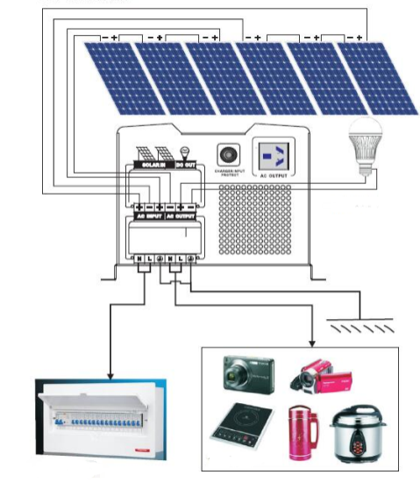
Solar wiring diagram

Note：

If connect to generator, must follow the steps below：

- Start generator, after it go stably, connect its output port to inverter’s input port (to be sure there isn’t any load connecting to inverter at this moment).
- Start the inverter, connect the loads one by one.

- Choose generator with 2 or 3 times capacity compared to inverter.
- Solar inverter’s panel and connection is different from common model.

- The voltage of solar panel should follow the Technical parameter.

Back panel connection
BATTERY Negative | Battery negative polarity connection
BATTERY Positive | Battery positive polarity connection
AC INPUT | AC input connection
AC OUTPUT | Universal socket output or terminal output
FUSE AC INPUT | Ac input voltage over current protection
FUSE AC OUTPUT | Ac output voltage over current protection

Note：

If connect to generator, must follow the steps below：

- Start generator, after it go stably, connect its output port to inverter’s input port (to be sure there isn’t any load connecting to inverter at this moment).
- Start the inverter, connect the loads one by one.

- Choose generator with 2 or 3 times capacity compared to inverter.
- Solar inverter’s panel and connection is different from common model.

- The voltage of solar panel should follow the Technical parameter.

6. Care and maintenance
●This series of inverter fairly needs maintenance. Turn to battery charge mode to extend the life of battery.

●discharge and charge the batteries at least 1 time every 6 months. Charging time should not be less than 12 hours.
●In high temperature area, battery should be charged and discharged every 2 months and standard charging time is not less than 12 hours.
●Basically batteries works 3-5 years, should replace when working not well.

●Ask professionals to replace the batteries.

Note：

- Before replacing battery, must PROitch off battery, inverter and mains supply.

- Put off the metal object like ring, watch etc.

- Use insulated tool and avoid putting any tool and metal object on battery.

- When connecting battery, it may strike some unharmful sparks.
- Do not make converse connection.

7. Solution for difficult situation

False | Cause | Solution
No city power input | Recoverable fuse popup | Press fuse back
Terminal heating | Fault or loose connection | Reconnect
Auto PROitch off with loads | Battery no power or overload | Charge battery or reduce loads
PROitch on failure | Fault connection with city power or battery | Check connection with battery or reconnect
Alarm when PROitch on | Battery no energy or overload | Charge battery or reduce loads
Buzzer screams 2 secs every 3 secs | Over temperature alarm (85℃-alarm，90℃-shut down) | Check if fan or vents jammed
Fan’s speed not stable | Smart control according to temperature | Leave it

8.Technical parameter
MODEL |  | BX1000VA | BX2KVA | BX2.5KVA | BX3KVA
RATED CAPACITY |  | 800w | 1600W | 2000w | 2400W
INPUT | VOLTAGE | (165-265)VAC
 | FREQUENCY | 45-65HZ
OUTPUT | VOLTAGE | 220V/±2%（BATTERY MODE）
 | FREQUENCY | 50/60HZ±1%（BATTERY MODE）
OUTPUT WAVEFORM |  | PURE SINEWAVE
EFFICIENCY |  | ＞85%
BATTERY |  | Lead-acid battery 24V
BATTERY RATED VOLTAGE |  | 12/24VDC |  | 24VDC
MAX AC CHARGING CURRENT |  | 10A(OPTIONAL)
SOLAR INPUT VOLTAGE |  | 30-60V
SOLAR CHARGE CURRENT |  | 30A
PROTECT |  | OVERLOAD,SHORT CIRCUIT,BATTERY HIGH AND LOW VOLTAGE AND AC INPUT HIGH AND LOW VOLTAGE PROTECTION
TRANSFER TIME |  | ≤6MS
CAPACITY OF OVERLOAD |  | 110-125% TURN TO BYPASS AFTER 60 SECS,150%MAINTAIN 10S AND THEN SHUT DOWN
COMMUNICATION PORT |  | RS-232/USB(OPTIONAL)
OPERATING ENVIROMENT | TEMPERATURE | -40~55℃
 | HUMIDITY | 10%-90%
CASE SIZE:L*W*H(mm) |  | 433*235*413mm
PACKAGE SIZE:L*W*H(mm) |  | 475*280*416mm
N.W/G.W(kg) |  |  |  | 13

