Power A Free Life






CONTENTS

ECOFLOW STORY
OUR TECHNOLOGY
RIVER 600
RIVER 600 MAX
RIVER 600 PRO
EF DELTA
SOLAR PANEL
ACCESSORIES
FOLLOW OUR STORY

01
06
09
11
12
16
21
24
25


ECOFLOW STORY

Our mission is to empower both individuals and communities
through portable, clean, reliable power a lasting impact by
replacing the traditional gas generator and reinventing the way
the world accesses energy.

Now, EcoFlow leverages their rich knowledge and experience
to build products that are thoughtful in design, smart, and
powerful. We strive to reinvent the way people everywhere
access power.

EcoFlow’s product lines equip our customers with a substantial
amount of clean, quiet, and renewable power for work,
adventures, and home backup power.

1


LITHIUM-ION BATTERY
GENERATOR

NO FUEL, NOISE, OR FUMES
No gasoline, toxic fumes, or noise/vibration during operation. The
EcoFlow Power Station is safe to use indoors.

NO MAINTENANCE
Easy to use, keep it plugged into a wall outlet or solar panel.

NO LOST POWER
Power is stored and consumed as needed, maximizing efficiency.

LOW COST
Costs 30% less than regular gasoline-powered inverter generators over its
lifetime.

2
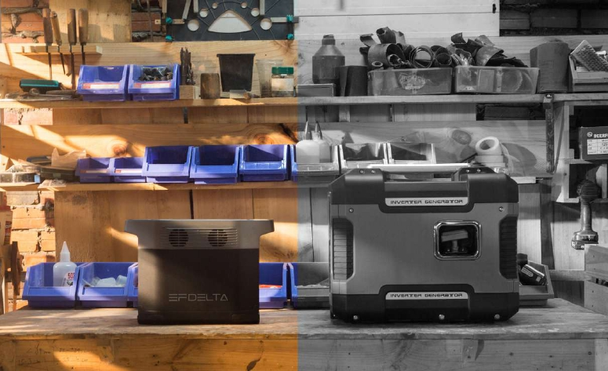

OUTDOORS
Enjoy your next adventure with full
power.
· Van Life
· Camping
· Festivals
· Tailgating

3
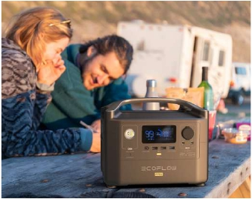







EMERGENCY
Always be prepared for the
unpredictable.
· Home Backup
· Disaster Relief
· Medical Devices

4
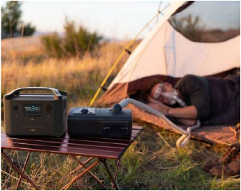

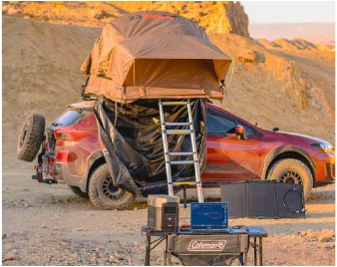

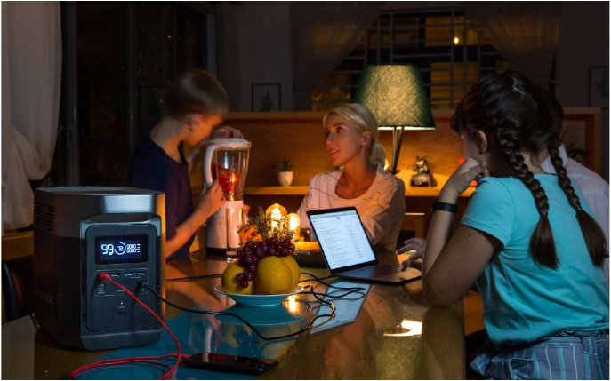

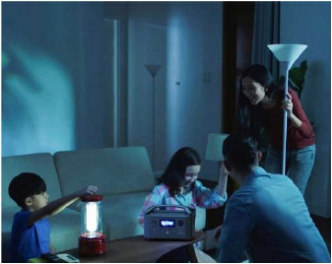

PROFESSIONAL

Get the job wrapped up with
uninterrupted power.

· DIY
· Film/Photography
· Event Production

5
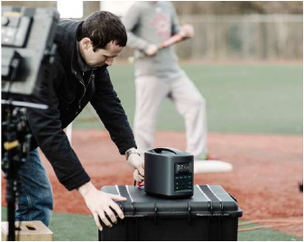

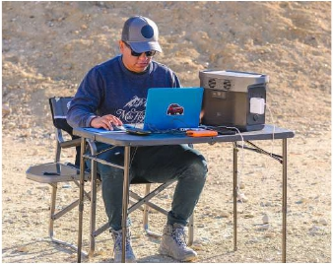

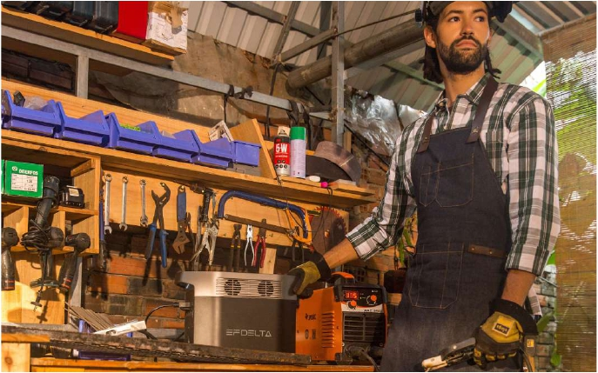

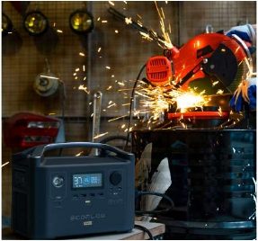

OUR TECHNOLOGY

Patented X-Stream Technology
From 0 to 80% Within 1 Hour

For the past three years, we've dedicated
our time and energy to create the X-Stream
Recharge Technology. This technology
provides the fastest recharge rate on the
market, recharging 5x times faster than
counterparts. This allows EcoFlow products
to be fully recharged within two hours using
any regular wall outlet.

Battery Management
System

We’ve developed our own prominent
Battery Management System to extend
the performance, lifecycle, and shelf-life
of EcoFlow products. This regulates all
the batteries inside the unit and manages
the health and efficiency of each one,
individually using AI algorithms.

Patented BMS System


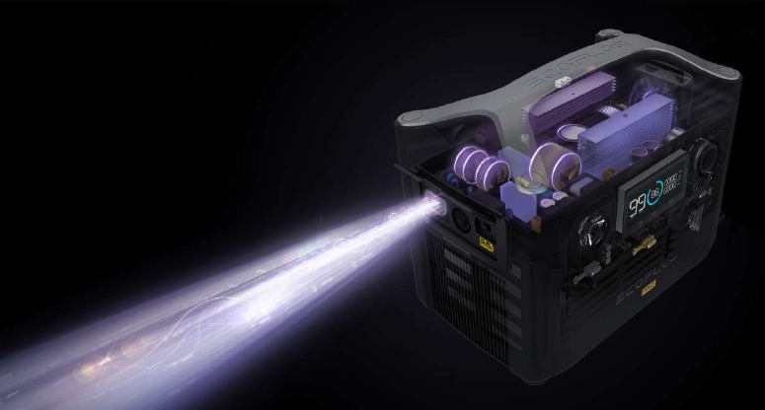

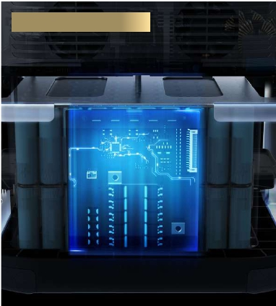

ECOFLOW APP

In this wireless world, remote control use is the standard. Now you can pair EcoFlow
products over Wi-Fi with the EcoFlow mobile app. It does everything straight from
the palm of your hand.

Download on the
App Store

Download for
Android
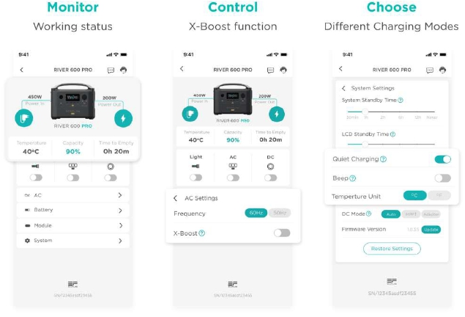

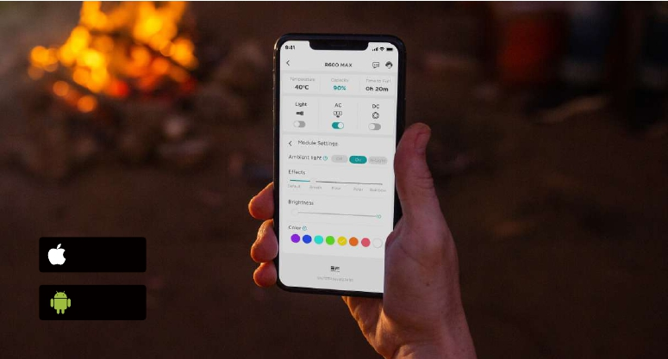

OUR PRODUCTS
Our product lines range from the powerful DELTA to the
flexible modular RIVER 600 series, which can fulfill your
power demand in many different scenarios.
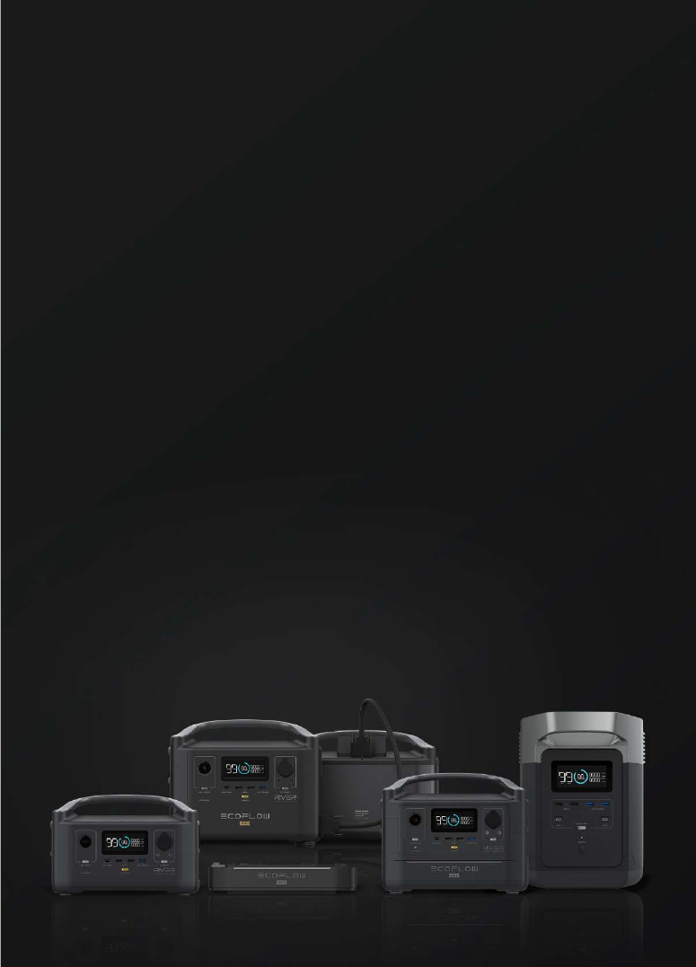

Portable Power Station

AC Output
600
(Surge 1200W)

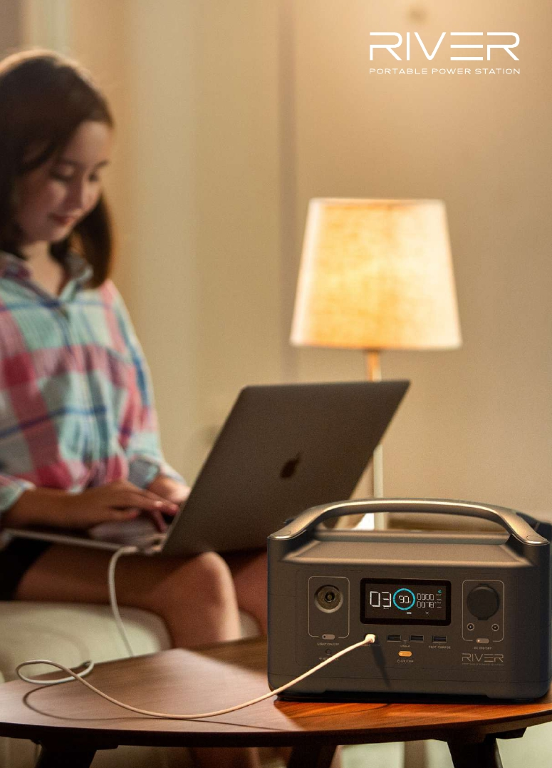

NEW

RIVER 600
RIVER 600, with its unprecedented modular
design, elevates the portable power station to a
whole new level of performance and efficiency. You
can customize your system to exactly what suits
you. Designed with a transformative 600W inverter
with X-Boost technology, RIVER 600 pushes the
boundaries of what a portable power station can
do.

OUTPUTS:
AC Output (x3/x2): 600W (Surge 1200W)
USB-A Output (x2): 12W per port, 5V DC, 2.4A
USB-A Fast Charge (x1): 28W, 5V DC,
9V DC,12V DC, 2.4A Max
USB-C Output (x1): 100W, 5V DC, 9V
DC,12V DC, 15V DC, 20V DC, 5A Max
Car Power Output (x1): 136W, 13.6V DC, 10A Max
DC5521 Output (x2): 13.6V DC, 3A Max (per port)

INPUTS:
AC Charge Input Power, X-STREAM: 250W Max
AC Charge Input Voltage: 100-120Vac (50Hz/60Hz)
(Int’l Version 220-240V)
Solar Charge Input: 200W 10-25V DC 12A Max
Car Charge Input: 12V/24V DC 10A Max

BATTERY:
Cell Chemistry: Lithium-ion
Cycle Life: 500+ Cycles (80%)
Discharge Temp: -4 to 140°F +/-5°F (-20 to 60°C +/-3°C)
Charge Temp: 32 to 113°F +/-5°F (0 to 45°C +/-3°C)

GENERAL SPECS:
Capacity: 288Wh
Weight: 11 lbs (5kg)
Dimensions: 11.3 x 7.3 x 7.7in (28.8 x 18.5 x 19.4cm)

10
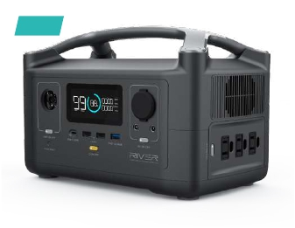

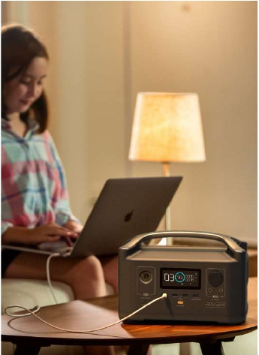

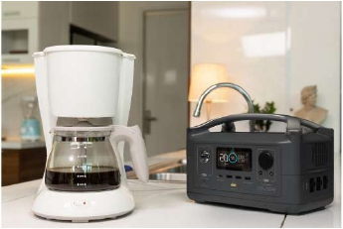

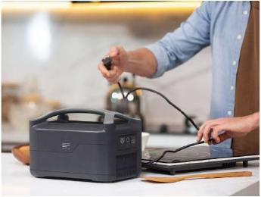

NEW

RIVER 600
By attaching the RIVER 600 Extra Battery, the
RIVER 600 Max doubles its capacity, but still
retains its portability and flexibility. You can
even set it to ambient light for date night.

OUTPUTS:
AC Output (x3/x2): 600W (Surge 1200W)
USB-A Output (x2): 12W per port, 5V DC, 2.4A
USB-A Fast Charge (x1): 28W, 5V DC, 9V DC,12V
DC, 2.4A Max
USB-C Output (x1): 100W, 5V DC, 9V DC,12V DC,
15V DC, 20V DC, 5A Max
Car Power Output (x1): 136W, 13.6V DC, 10A Max
DC5521 Output (x2): 13.6V DC, 3A Max (per port)

INPUTS:
AC Charge Input Power, X-STREAM: 500W Max
AC Charge Input Voltage: 100-120Vac (50Hz/60Hz)
(Int’l Version 220-240V)
Solar Charge Input: 200W 10-25V DC 12A Max
Car Charge Input: 12V/24V DC 10A Max

BATTERY:
Cell Chemistry: Lithium-ion
Cycle Life: 500+ Cycles (80%)
Discharge Temp: -4 to 140°F +/-5°F (-20 to 60°C +/-3°C)
Charge Temp: 32 to 113°F +/-5°F (0 to 45°C +/-3°C)

GENERAL:
Capacity: 576Wh
Weight: 17 lbs (7.7kg)
Dimensions: 11.3 x 7.3 x 9.96in (28.8 x 18.5 x 25.3cm)

11
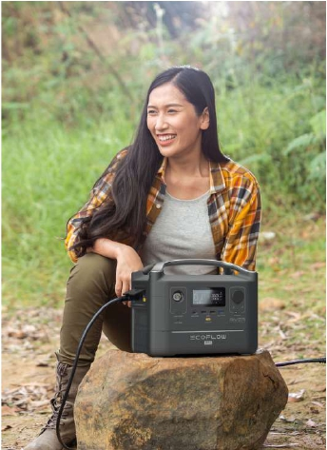

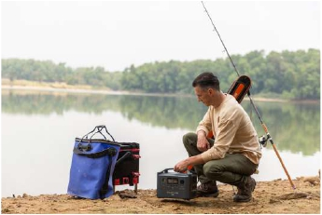

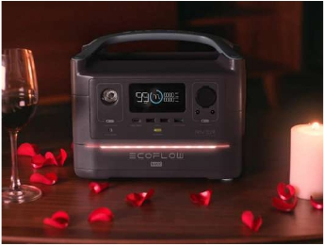

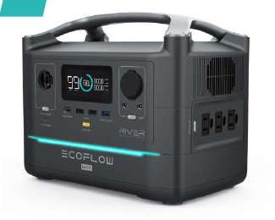

NEW

RIVER 600
The RIVER 600 PRO is designed for users seeking
a power solution with a longer runtime. With
the 720Wh lithium-ion battery pack and built-in
EcoFlow BMS, the RIVER 600 PRO enjoys 500+
lifecycles and can easily expand to a capacity of
1440Wh by connecting the RIVER 600 PRO Extra
Battery with just a simple cable.

OUTPUTS:
AC Output (x3/x2): 600W (Surge 1200W)
USB-A Output (x2): 12W per port, 5V DC, 2.4A
USB-A Fast Charge (x1): 28W, 5V DC, 9V DC,12V
DC, 2.4A Max
USB-C Output (x1): 100W, 5V DC, 9V DC,12V DC,
15V DC, 20V DC, 5A Max
Car Power Output (x1): 136W, 13.6V DC, 10A Max
DC5521 Output (x2): 13.6V DC, 3A Max (per port)

INPUTS:
AC Charge Input Power, X-STREAM: 660W Max
AC Charge Input Voltage: 100-120Vac (50Hz/60Hz)
(Int’l Version 220-240V)
Solar Charge Input: 200W 10-25V DC 12A Max
Car Charge Input: 12V/24V DC 10A Max

BATTERY:
Cell Chemistry: Lithium-ion
Cycle Life: 500+ Cycles (80%)
Discharge Temp: -4 to 140°F +/-5°F (-20 to 60°C +/-3°C)
Charge Temp: 32 to 113°F +/-5°F (0 to 45°C +/-3°C)

GENERAL:
Capacity: 720Wh
Weight: 16 lbs (7.2kg)
Dimensions: 11.3 x 7.3 x 9.96in (28.8 x 18.5 x 25.3cm)

12
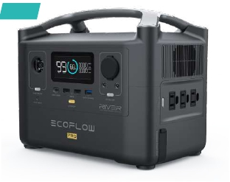

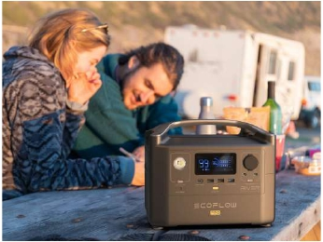

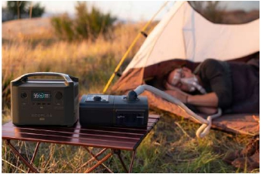

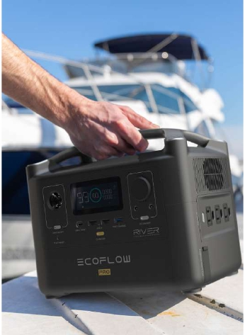

NEW

RIVER 600 PRO
EXTRA BATTERY

The RIVER 600 PRO Extra Battery, with 500+
lifecycles, can double the capacity of the
entire system when connected to the RIVER
600 PRO.

OUTPUTS:
Expansion Power Port: 600W Max

INPUTS:
Expansion Power Port: 660W Max

BATTERY:
Cell Chemistry: Lithium-ion
Cycle Life: 500+ Cycles (80%)
Discharge Temp: -4 to 140°F +/-5°F (-20 to 60°C +/-3°C)
Charge Temp: 32 to 113°F +/-5°F (0 to 45°C +/-3°C)

GENERAL:
Capacity: 720Wh
Weight: 15.4 lbs (7kg)
Dimensions: 11.3 x 32.4 x 6.5in (28.8 x 21.7 x 16.5cm)

13
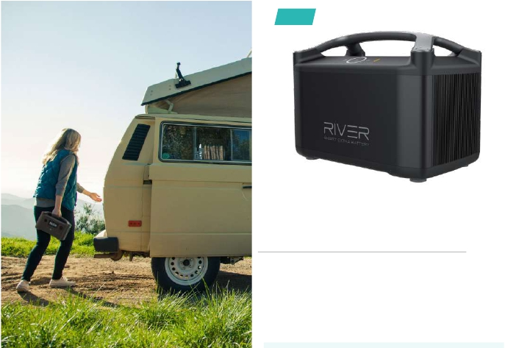

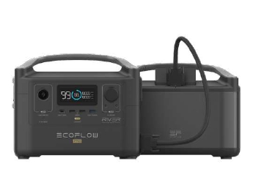

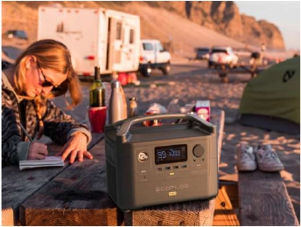

1. LCD Display
Display various conditions of the product.
2. LED Light Control Button
There are three types of LED light: low light,
strong light, and SOS rescue signal flash.
3. IOT Reset Button
Used to reset the Wi-Fi.
4. USB-C 100w Output Port
The 100W USB-C port can support output power
up to 100w, you can even charge a laptop.
5. USB-A Output Ports
Charge a wide spectrum of devices including
iPhone, tablet, GoPro, speakers, or anything else
that can be charged through a USB Port.
6. Fast Charge USB-A Output Port
Fast-charge enabled devices can be charged at
a maximum output of 28W.
7. Power Button
Press and hold the button to turn RIVER 600 on
or off.
8. DC Output Port (Car Outlet, 2 Dc
5521 Output Ports) DC Output Indicator
The DC 12V port is used to charge appliances
like mini PC, projector, Wi-Fi Router or 12V Light.
The car cigarette output port can be used for a
car fridge.

1

9. Ventilation Fan
The fan prevents RIVER 600 from overheating.
10. 3*AC Output Sockets (100-120v)
2*AC Output Sockets (220-240v)
The powerful AC output sockets can support
your daily home appliances, and with the X-boost
feature on, it can even be used for a kettle.
11. AC Power Button
The AC power button controls the AC output of
the RIVER 600.

12. Expansion Power Port
This port is used to connect the RIVER 600 PRO
Extra Battery to provide increased capacity.

13. X-Stream Charging Input Port
The fastest X-stream charging input port in the
industry, AC recharge 0-80% within one hour.
14. Overload Protection Switch
When the input current continuously exceeds
10A during a charge, the AC charging port will
trigger the overload protection.
15. Power Earth Screw
The power earth screw provides an option to get
your RIVER 600 grounded using a grounding cable.
16. Solar Charge/Car Charge Input Port
Support a maximum of two 110W solar panels
to be connected in parallel. It also supports a
12V/24V car charge up to 10A.

2

4

5 6

10
9

13 14 15

11
16

7

12

14
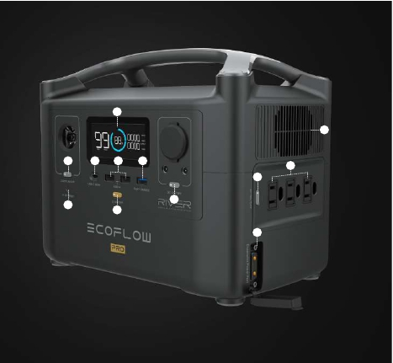

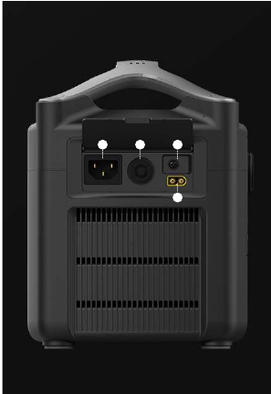

3 8

RIVER 600 SERIES
COMPARISONS

RIVER 600 RIVER 600 MAX RIVER 600 PRO RIVER 600 PRO
with Extra Battery

15
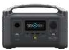

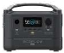

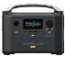

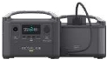

Capacity | 288Wh | 576Wh | 720Wh | 1440Wh
Battery Chemistry | Lithium-ion | Lithium-ion | Lithium-ion | Lithium-ion
Shelf Life | 1 Year | 1 Year | 1 Year | 1 Year
Cycle Life | 500+(80%) | 500+(80%) | 500+(80%) | 500+(80%)
AC Output | 600W  (Surge 1200W) | 600W  (Surge 1200W) | 600W  (Surge 1200W) | 600W  (Surge 1200W)
AC Ports | 3 | 3 | 3 | 3
Type-C PD Ports | 100W  (Support Macbook Pro) | 100W  (Support Macbook Pro) | 100W  (Support Macbook Pro) | 100W  (Support Macbook Pro)
Total Ports | 10 | 10 | 11 | 11
Wall Charging | 250W Max | 550W Max | 660W Max | 660W Max
Wall Charging Time | 1.6 Hours | 1.6 Hours | 1.6 Hours | 3 Hours
Universal Solar
Charging (MC4)
Solar Panel  Charging | 200W  (110W*2) | 200W  (110W*2) | 200W  (110W*2) | 200W  (110W*2)
Solar Panel  Charging Time | *1.6-3 Hours  (110W*2) | *3-6 Hours  (110W*2) | *4-8 Hours  (110W*2) | *8-16 Hours  (110W*2)
APP
Weight | 11 lbs | 17 lbs | 16 lbs | 32 lbs

Lithium-ion Battery Generator

AC Output Capacity
1800 1260
(Surge 3300W) Wh


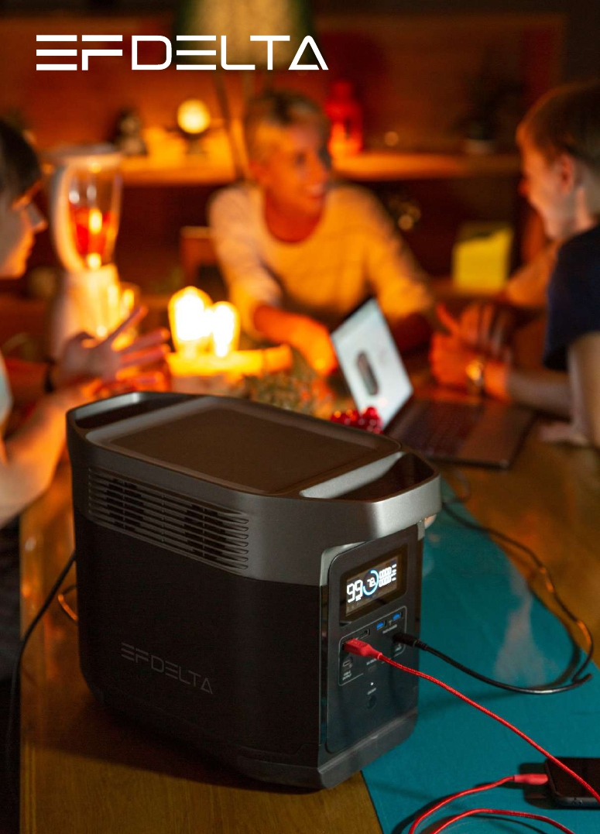

EF DELTA

EF DELTA, the lithium-ion battery generator
with high power output, large capacity, and
groundbreaking recharging technology. Has
the same power as a traditional gasoline
generator, but without noise, emissions, and
high maintenance fees.

OUTPUTS:
AC Output (x6)/AC Output (x4): 1800W (Surge
3300W) total, 120Vac (60Hz)/230Vac (50Hz)
USB-A Output (x2): 12W 5V DC, 2.4A Max, per port
USB-A Fast Charge (x2) : 28W 5V DC, 9V DC, 12V
DC, 2.4A Max, per port
USB-C Output (x2): 60W 5V DC, 9V DC, 15V DC,
20V DC, 3A Max, per port
Car Power Output (x1): 108.8W, 13.6V DC, 8A Max

INPUTS:
AC Charge Input Voltage: 100-120Vac (50Hz/60Hz)
ONLY! (International Version 220-240Vac ONLY!)
AC Charge Input Power: 1200W Max
Solar Charge Input: 400W 10-65V DC 10A Max
Car Charger: 12V/24V DC 10A Max

BATTERY:
Cell Chemistry: Lithium-ion
Cycle Life: 800+ Cycles (60%)
Discharge Temp: -4-140°F +/-5°F (-20-60°C +/-3°C)
Charge Temp: 32-113°F +/-5°F (0-45°C +/-3°C)

GENERAL:
Capacity: 1260Wh
Weight: 30.9lbs (14kg)
Dimensions: 15.7 x 8.3 x 10.6in (40 x 21 x 27cm)

17
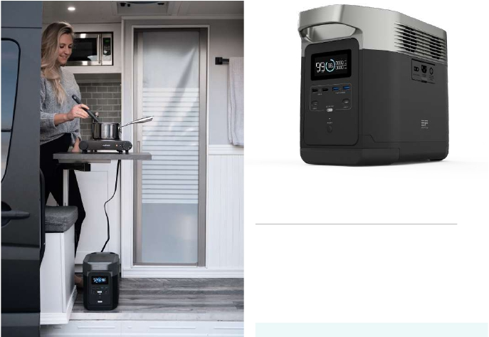

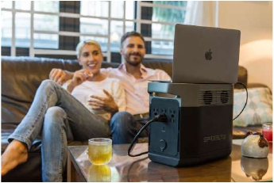

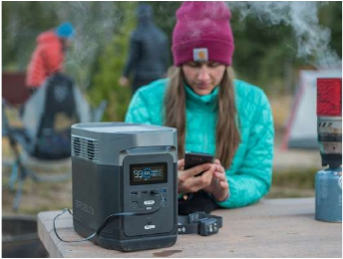

1

7 8

9

10

2

3

3
4 11

5

6

1. LCD Display
Display the various conditions of the product.
2. USB-A Output Ports
Charge a wide spectrum of devices including
iPhone, tablet, GoPro, speakers, or anything
else that can be charged through a USB port.
3. Fast Charge Usb-A Output Ports
Charge devices at double the speed.
4. USB-C Output Ports
Charge your laptop, mobile phone etc.
5. DC On/Off Switch
Control the DC output.
6. Power On/Off Button
Press and hold the power button to turn the EF
DELTA on or off.
7. Solar Charge/Car Charge Input Port
Support a maximum of four 110W solar panels
to be connected. It also supports a 12V/24V car
charge up to 10A.

12

8. X-Stream AC Charge Input Port
The X-stream charging input port in the industry,
AC recharge 0-80% within one hour.
9. Overload Protection Switch
When the input current continuously exceeds 20A
during a charge, the AC charging port will trigger
the overload protection.
10. 6*AC Output Sockets (100-120v)
4*AC Output Sockets (220-240v)
Charge devices, such as laptop, electric guitar, TVs,
mini refrigerator, vacuum etc.
11. AC Power Button
The AC Power Button controls the AC output of EF
DELTA.
12. Car Outlet
Charge devices like a drone battery, car fridge or
any device using a car socket.

18
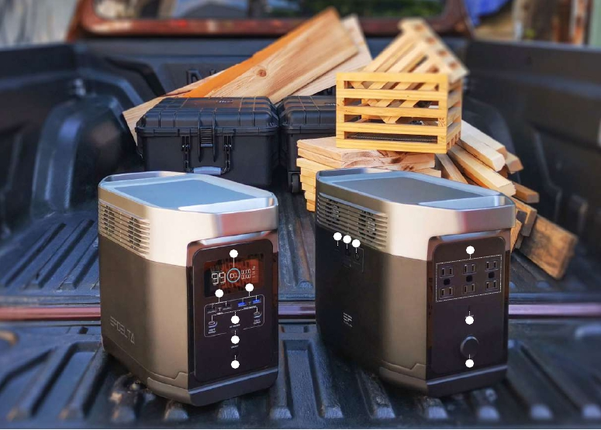

RUN TIMES

RIVER 600 RIVER 600 MAX RIVER 600 PRO EF DELTA

LIGHT

12 Hours

24 Hours

32 Hours

60 Hours

(10W)

14 Times 28 Times 38 Times 63 Times

PHONE
(18Wh)

2.5 Times

5 Times

7 Times

11.5 Times

LAPTOP
(99Wh)

10 Times

21 Times

27 Times

45 Times

SONY A7IV
(25Wh)

2-4 Hours

4-8 Hours

5-10 Hours

8-16 Hours

TELEVISION
(110W)

GRILL

0.4 Hours

0.8 Hours

1 Hours

0.6-1.2 Hours

(1650W)

CPAP

5-10 Hours

10-20 Hours

13-26 Hours

20-40 Hours

(40W)

REFRIGERATOR

1.5-3 Hours

3-6 Hours

4-8 Hours

6-10 Hours

(150W)

19



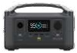

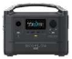

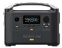

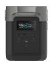

CHARGING TIMES

RIVER 600 RIVER 600 MAX RIVER 600 PRO

EF DELTA

INCLUDED
POWER SUPPLY

1.6 Hours

1.6 Hours

1.6 Hours

1.6 Hours

1.6 Hours

1.6 Hours

1.6 Hours

1.6 Hours

GAS GENERATOR

3 Hours

5 Hours

6.5 Hours

10 Hours

CAR CHARGER

SOLAR PANEL
(110W)

1.6-3 Hours

（110W*4）

SOLAR PANEL

7 Hours

14 Hours

19 Hours

(60W)

SOLAR CHARGING
RECOMMENDATIONS

RIVER 600 RIVER 600 MAX RIVER 600 PRO

EF DELTA

LITE USE
20% DAILY

60 WATTS 60 WATTS 60 WATTS 110 WATTS

MEDIUM USE
50% DAILY

110 WATTS

110 WATTS 110 WATTS 330 WATTS

HEAVY USE
100% DAILY

220 WATTS 220 WATTS 220 WATTS 440 WATTS

20



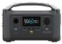

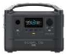

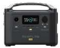

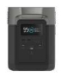

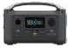

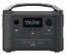

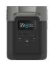

（110W*2） 3-6 Hours
（110W*2） 4.5-9 Hours
（110W*2） 4-8 Hours

SOLAR PANELS
Whetheryou're recharging aa portablerefueling portable power
monocrystallineportable panel monocrystalline solar panels are
rugged,Providing power in an eco-friendly manner.
Harness the sun to power your life.

21
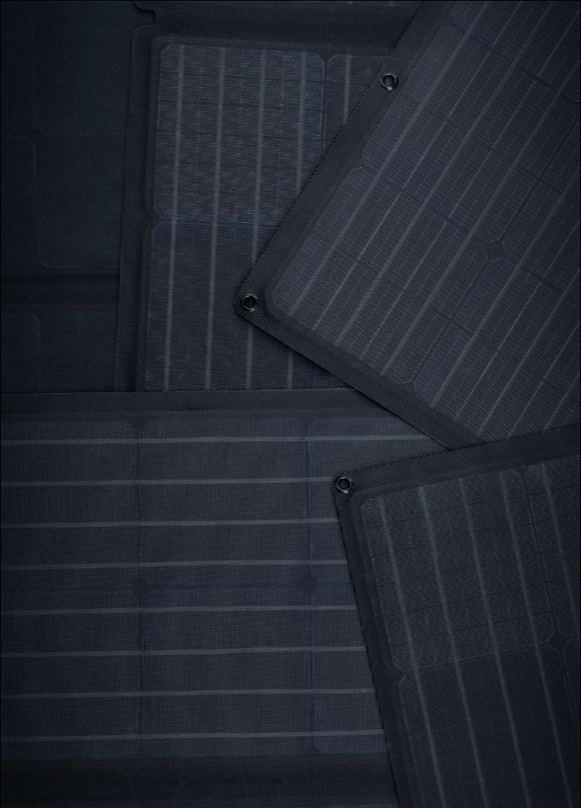

When phone power station, our
station, our solarline of efficient, reliable, and easy
to use. reliable, and easy to use.

60W SOLAR PANEL

The 60W solar panel is lightweight for easy
transporting and convenient to operate. Plug in
and power whenever and wherever.

60W SOLAR PANEL:
Rated Power: 60W (+/-5W)
Open Circuit Voltage: 21.6V (Vmp 18.2V)
Short Circuit Current: 3.5A (Imp 3.3A)
Efficiency: 21-22%
Cell Type: Monocrystalline silicon

OUTPUT PORTS:
MC4 Solar Port to XT60: 80V (Max), up to 10A (Max)

GENERAL:
Weight: 7.7 lbs (3.5KG) Solar Panel 4.4lbs (2.0KG)
Waterproof IP Ratings: IP67
Unfolded Dimensions: 21*32.1*0.8in (53.7*81.5*2cm)
Folded Dimensions: 21*16.5*0.8in (53.7*42*2cm)

22
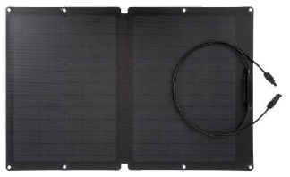

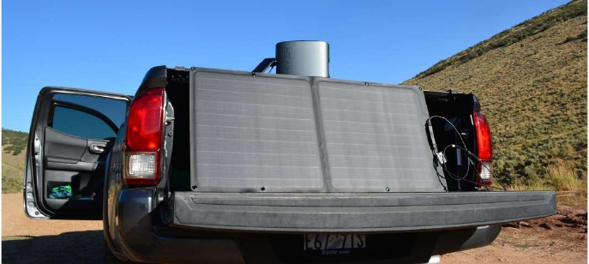

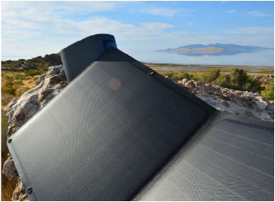

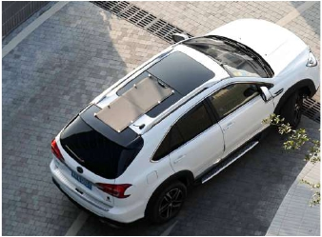

110W SOLAR PANEL:
Rated Power: 110W(+/-5W)
Open Circuit Voltage: 21.7V(Vmp 18.5V)
Short Circuit Current: 6.3A(Imp 6.0A)
Efficiency: 21-22%
Cell Type: Monocrystalline silicon

OUTPUT PORTS:
MC4 Solar Port to XT60: 80V(max), up to 10A (max)

GENERAL:
Weight: 13.2 lbs(6KG) Solar Panel 8.8 lbs(4.0KG)
Waterproof IP Ratings: IP67
Unfolded Dimension: 20.2*62.5*0.8in (51.4*158*2.0cm)
Folded Dimension: 20.2*16.5*0.8in (51.4*42*2.0cm)

110W SOLAR PANEL

Live off the grid with your 110W solar panels.
Created from the most efficient monocrystalline
silicon cells, recharge the EF DELTA or RIVER,
and keep your equipment running without
interruption.

23
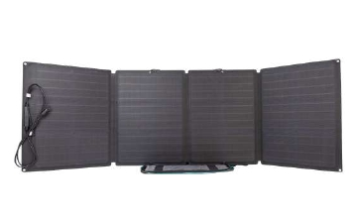

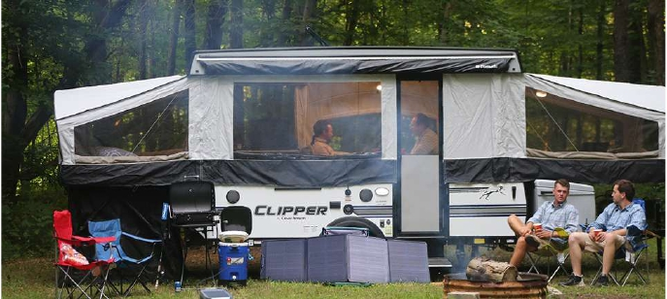

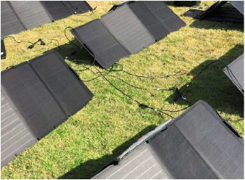

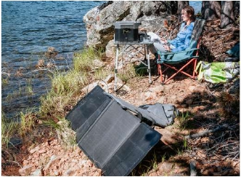

ACCESSORIES

24
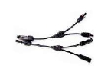

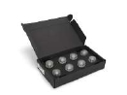

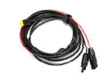

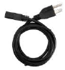

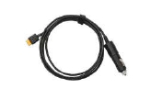

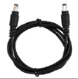

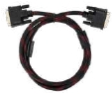

PRODUCT | NAME | DESCRIPTION
 | Solar MC 4 Parallel  Connection Cable | Solar MC 4 parallel connection cable can be used to  connect 4 or 6 solar panels to charge your EcoFlow  product.
 | Suction Cups for  Solar Panel | Suction Cups (8pcs per package):  Easy to attach to glass, the car roof, and other  smooth surfaces. Best method of securing solar  panels.
 | MC4 to XT60 Solar  Panel Charging Cable | With this EcoFlow MC4 to XT60 cable, a solar panel  with a standard MC4 output can be connected to  the power station.
 | AC Charging Cable | Connect to a wall outlet to recharge your power  station.
 | Car Charging Cable | Connect your car to recharge your power station.
 | DC5521-DC5525 Cable | Connect appliances with DC type port. e.g,  computer monitor, mini-computer, LED light, Wi-Fi  router.
 | Expansion Power Cable | Connect your RIVER 600 PRO with a RIVER 600  PRO extra battery.

Follow Our Story

Follow Us:

Facebook:
@EcoFlowTech

Contact Us:

Instagram:
@EcoFlowTech

Twitter:
@EcoFlowTech

Support

Wholesale Marketing

support@ecoflow.com
sales@ecoflow.com
(North America & Others)
sales-EU@ecoflow.com
(Europe&Australia)
marketing@ecoflow.com

25










POWER A FREE LIFE

www.ecoflow.com



