DX-600/1000W Lithium Portable Solar Power Station
User’s Manual
1. Power everywhere,wonderful life
DX-600 Series Li-battery portable power supply:
It is a pure sine wave UPS backup power product which featured with lightweight, portable, beautiful design, easy-to-use and built-in large-capacity lithium battery. It adopts advanced built-in lithium battery technology and has strong output energy. It provides two different voltage modes: AC output and DC output, which can meet the power supply for different electronic products. This product can be used not only as an online UPS power supply, but also as an outdoor emergency backup power supply. It can provide power supply for most mobile electronic products.
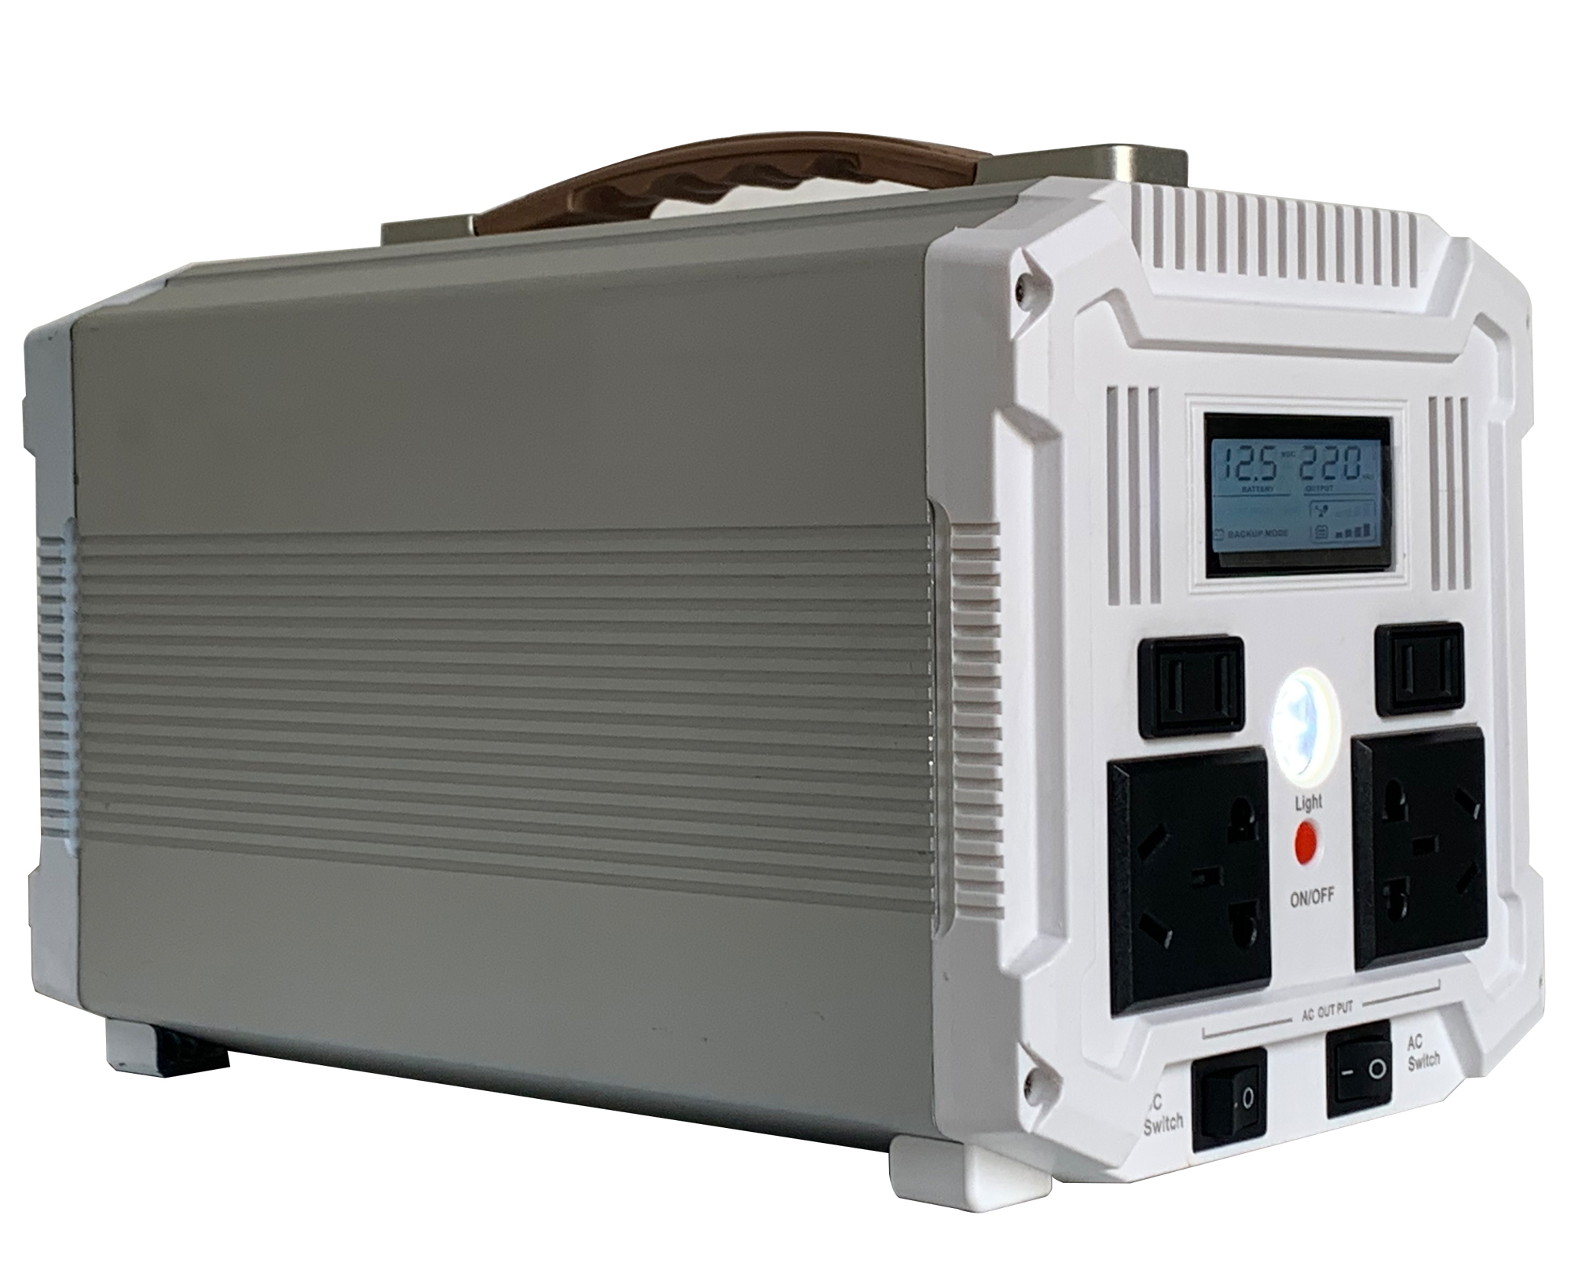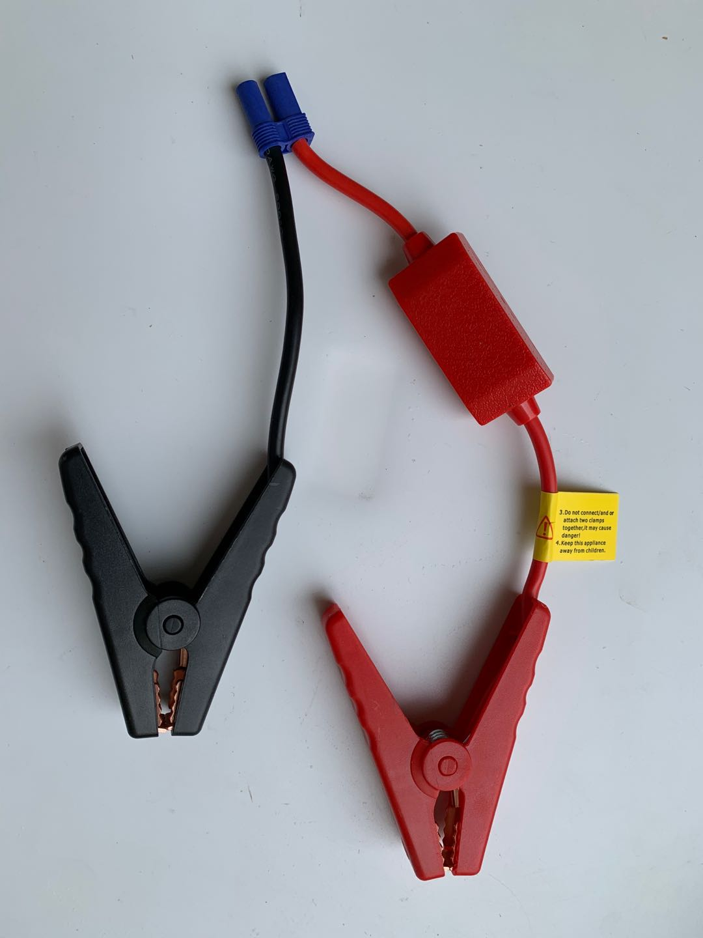
There is a built-in high-capacity long-life lithium battery pack which rated 12V 26-90AH /288~990Wh to provide a continuous power. After normal power off, this UPS can provide continuous power for common home/office desktop computers for 5-20 hours. Meanwhile, it also can used as an indoor or outdoor emergency power supply. Its 220VAC/12VDC/5VDC output, is suitable for various devices,like mobile phones, tablet PC, laptops, small printers, various lamps, small fish tank heaters, photographic equipment, electric balance car, medical equipment, etc. Compared with traditional UPS, this product is actually a must-have product for home, travel, outdoor work, camping, picnic, and mountaineering adventure.

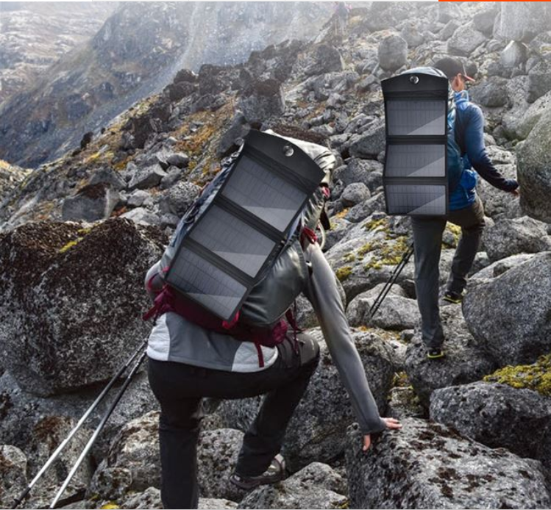
mountaineering adventure camping
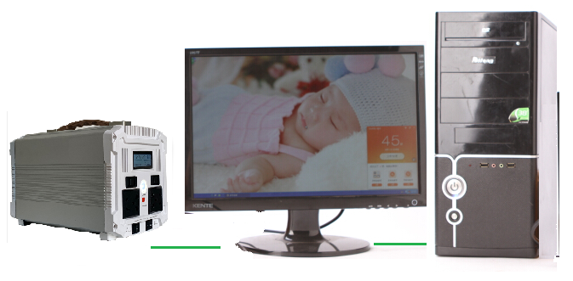
Commercial & Office Mobile Office



Outdoor construction Outdoor camping
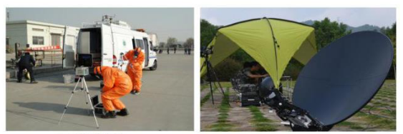
Environmental monitoring Outdoor communication
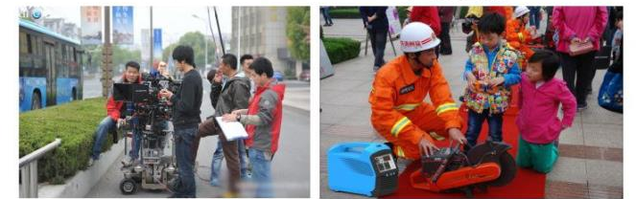

Filming Fire emergency

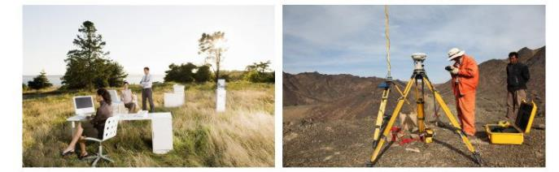
Power detection Troop drill

Outdoor office Outdoor survey

2. Function introduction and instructions
- Product overview(front side)

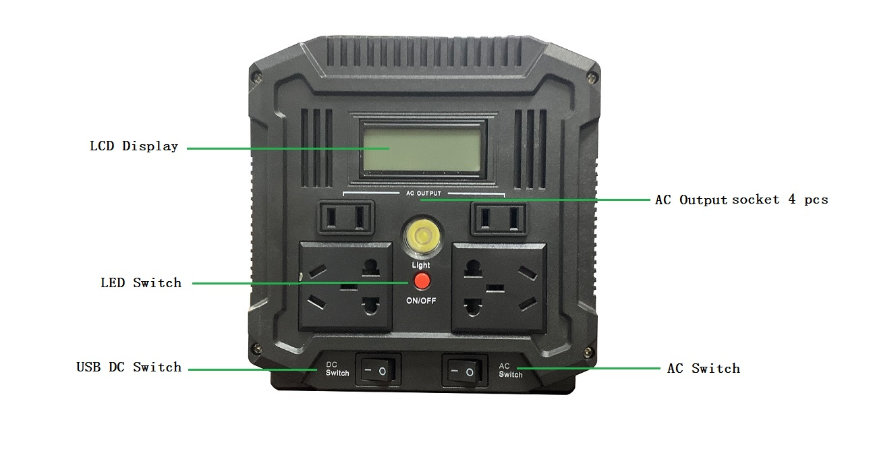When using the DC output function, please turn on the corresponding DC switch , then the DC output indicator will light up. At this time, DC 12V and 5V output can be used. When not in use, please turn off the switch to avoid self-consumption of the power. The LCD display can show the power level:0~100%. When the battery power is low, please charge the power station in time for continued use. When using the LED torch , please turn on the corresponding LED power switch.

LCD function display:
Normal power charging status:
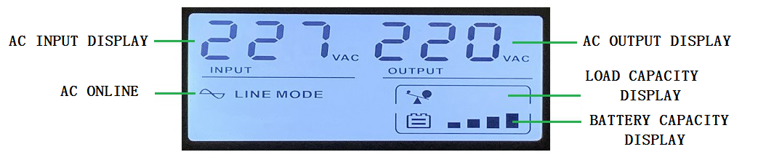

When Normal power Off, The status of battery power supply

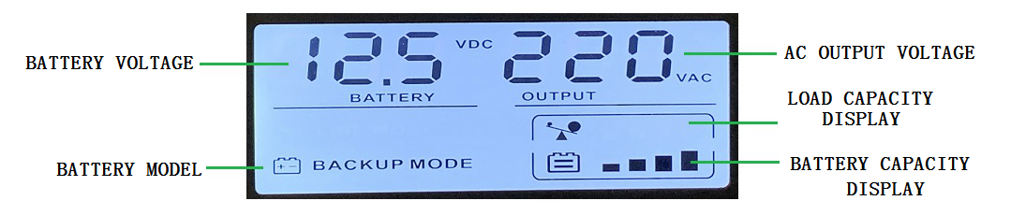
- Product overview(Back side)

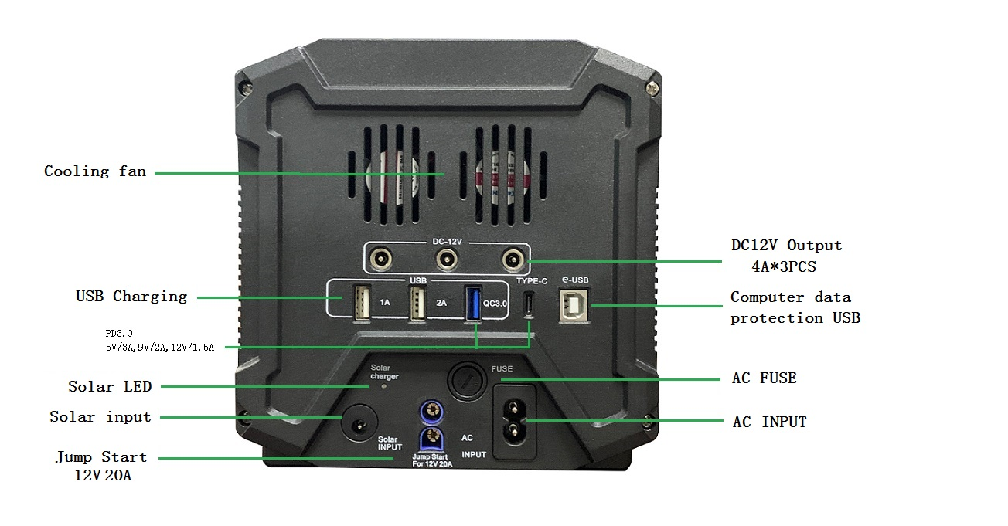
As pictures shows, please plug the AC input power cable into the AC INPUT port before using it. Then connect the load , and turn on the AC output switch for normal use. When normal power is working, the normal power will working for the load. At the same time, the product is also charged. When the normal power off, it will automatically switch to the internal battery to supply power for the load.
Please note: When the unit connected with a load, the operating power of the load should not exceed the maximum output power of the unit. For example: the maximum output power of the unit is 600W, if the operating power of the load exceeds 600W, the power supply will enter the protection state and shut down the output. Only when the excess load is reduced and the unit is restarted, the output power can resume its normal power output. If a heavy load is connected to the unit, it may cause the AC fuse blow off. Please replace the blown fuse with a 8A 250V fuse and verify the connected total load doesn’t exceed the maximum rated power of the unit before attempting to using the unit again.
When bring it for outdoor use, please turn off all switches at standby times, in order to miniumize the automatic consumption of the battery, only and turn them on when you need to use this UPS.

Solar charging description: As picture show “Solar charging input”, and the suitable solar panel specification is 18V, 50W~120W. When connecting the solar panel, pay more attention to the positive pole and negative poles, and they should correspondingly connect the positive and negative poles (internal positive and external negative), otherwise it cannot be charged.
e-USB intelligent computer data management and remote monitoring functions:
1. Install WinUPSmate communication management software on the computer
2. The computer pops up a friendly interface, Pls connect the data line between the computer and the UPS
3. The interface will show that the UPS has been connected normally and you can enter the intelligent data storage management
4. Install the APP app by scanning the QR code on the mobile phone interface
5. When the computer is connected to the Internet, the mobile phone can automatically monitor the UPS working status

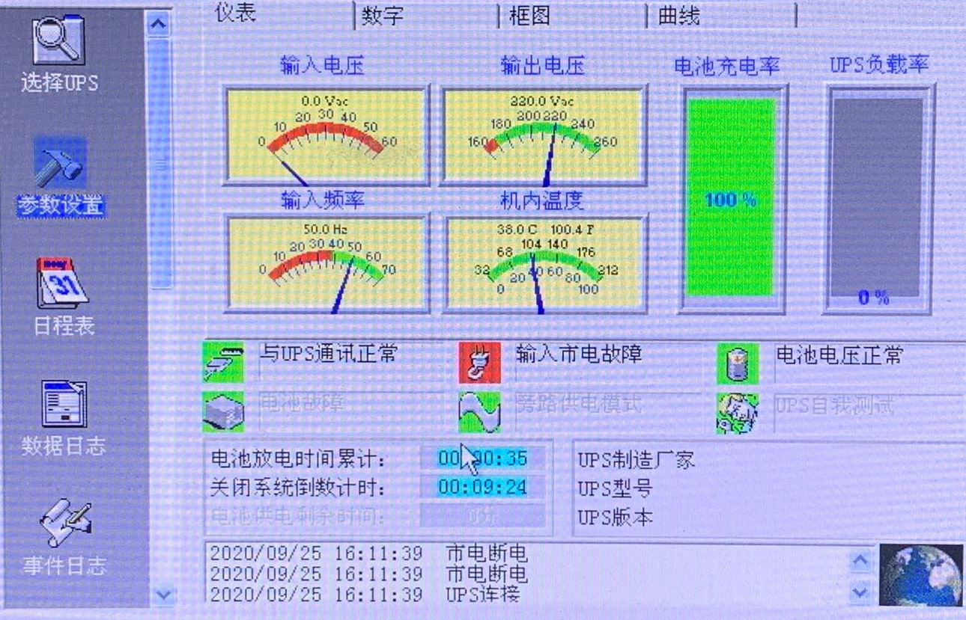
3.Technical data
Model | DX-600 UPS-600B UPS-600C | DX-1000 | DX-1200
Battery | 12V 45Ah(531WH) | 12V 70AH(986WH) | 12V80AH(1131WH)
Output power | 600W 1000W 1200W
Input voltage | AC input: AC 110V~220V 50/60Hz;Solar /wind energy input: DC 13-30V input; vehicle input: 12V , without controller.
Output voltage | 220V 50Hz / 110V 60Hz
DC output | Three 12V/4A; two USB5V/2.1A; one QC3.0; one TYPE-C; one (PD3.0 fast charge  5V/3A, 9V/2A, 12V/1.5A);
Smart communication | 1 universal USB for computer data monitoring (mobile Internet monitoring function, optional)
LED Light | 1W
Solar Charger | 18V60W/ 120W (optional）
Input Wave | Pure sine wave
Transfer time | ≤5ms
Over load | If overload, the AC output is disconnected, the indicator light is red, after disconnect the load, Then restart the UPS, then recover working normally
Short circuit | when short circuit, the AC output is disconnected, disconnect the load, after disconnect the load, Then restart the UPS, then recover working normally
Lithium battery | More than 600 times for the cycle life
Net weight | 5.95kg 8.9kg 9.3kg
Gross weight | 7.2kg 10.2kg 11.2kg
Product Size | 266*160*168mm 380*160*168mm 415*160*168mm
Packing Size | 380*230*225mm 468*230*225mm 478*230*225mm
Color | Silver/Gray/black (customized)

4. Working principle
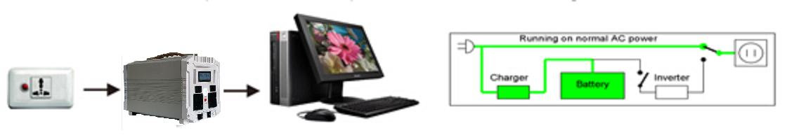
When the mains power is working, it will supply power to this UPS and charges this UPS at the same time.
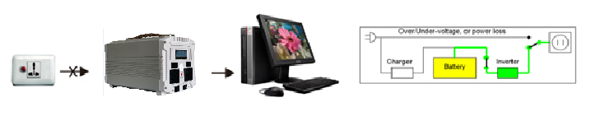
When sudden power off, The UPS will be automatically switched to internal lithium battery supply power to the equipment in an instant.The computers will continue to work without shutting down!

5.Backup time
Equipment(Load) | DX-600 | DX-1000 | DX-1200
Cellphone 5V | More than 48 times | More than 90 times | More than 100 times
LED light 12V | 3W about 150 hours | 3W about 300 hours | 3W about 310 hours
Desktop computer | About 8 hours | About 16 hours | About 20 hours
Ornamental fish tank | About 12 hours | About 24 hours | About 30 hours
Laptop | About 11-12 hours | About 22-24 hours | About 22-28 hours
Fan 50W | About 9 hours | About 16 hours | About 18 hours
32 inch LCD TV | About 8 hours | About 16 hours | About 18 hours
20W Energy saving lamp | About 23 hours | About 46 hours | About 49 hours
Inverter refrigerator | About 12 hours | About 24 hours | About 28 hours
500W Rice cooker | About 1-2 times | About 2-4 times | About 2-6times
Automatically changeover switch after normal power off (uninterrupted power)

6. Comparison of similar products
Old-design UPS power supply has big size and difficult to be carried. Meanwhile,The service life is short, and the internal battery must be replaced within one year. The capacity of battery is also small, generally only standby about ten to twenty minutes. It is also not satisfactory in terms of environmental protection and energy saving. This UPS abandons the various disadvantages of the old-design UPS power supply and has a subversive design. The lithium-ion online UPS backup power supply is only 1/5 of the old UPS power supply, its weight is only 6.0kg, and has a life span of three to five times than old-design UPS. The capacity also greatly exceeds the old-design UPS power supply. In terms of practicality, compared to the old-design UPS power supply, this product has added 1 car ignition, 3pcs 12V, 2pcs 5V, 1pcs QC3.0, 1pcs TYPE-C in addition to the AC output. The DC output interface and LED lighting can supply power to multiple mobile devices at the same time, so that when you go have a trip, you can ensure that all kinds of mobile devices are supplied with power. The exclusive E-USB functional interface is an upgraded interpretation of today's smart home appliances.Its efficient and safe lithium battery and high frequency inverter technology makes this product not only convenient and practical, but also a model of environmental protection, energy saving and high efficiency.
7.Packing list
No. | Name | Quantity
1 | Mobile power main engine | 1
2 | AC power wire | 1
3 | Computer online USB wire | 1
4 | Instruction warranty card | 1
5 | Qualified card | 1
6 | Advanced mobile package(optional) | 1
7 | Folding solar panel 18V 60/120W(optional) | 1
8 | Car start ignition wire clamp (optional) | 1
8.Notices
1.This product contains lithium batteries, please keep away from fire, if no use, please make special treatment, do not throw away randomly
2. Do not use this product in a humid environment or in water, pay attention to moisture, try to use it in a ventilated and dry environment
3. When using the product, please handle it gently, and do not drop, knock or violently disassemble it.
4.If you find abnormal phenomena such as smoke or fire during use of the machine, please stop using it immediately and take relevant fire-fighting measures to avoid explosion
5.When using this product, please turn it on first, turn on the corresponding switch and the LED indicator light to confirm that there is output before using it.
6.Please refer to the instruction manual when using this product for the first time.
7.When this product is not in use, please take it out and charge it every three months so to ensure battery life.

9..1Wide range of electrical appliance can be used

- .2 Color choices


